**PROJECT REPORT TEMPLEATE**

**PROPERTY MANAGEMENT APPLICATION USING SALESFORCE**

**TEAM ID: NM2023TMID1955**

**1.INTRODUCTION**

**1.1 Overview:**

Property Management enables the Salesforce For Real Estate companies to keep a track of crucial data about financial & household properties incorporating associated cash flow, primary tenants, and occupancy rates.

**1.2 Purpose:**

Your renters need more than just shelter — they need a property manager they know they can trust. With real estate management software from Salesforce, you can give your renters the support they need. Contact Salesforce today and start building relationships.

Property managers assist owners in creating budgets, advertise rental properties, qualify tenants, and collect rent.

**2.Problem Definition & Design Thinking**

**2.1 Empathy map:**

An empathy map is a collaborative visualization used to articulate what we know about a particular type of user. If externalizes knowledge about users in order to

1. Create a sharted understanding of user needs, and
2. Aid in decision making

**EMPATHY MAP**

|  |  |
| --- | --- |
| PROJECT NAME | PROPERTY MANAGEMENT APPLICATION USING SALESFORCE |
| TEAM ID | NM2023TMID19554 |
| DATE | 15.04.2023 |

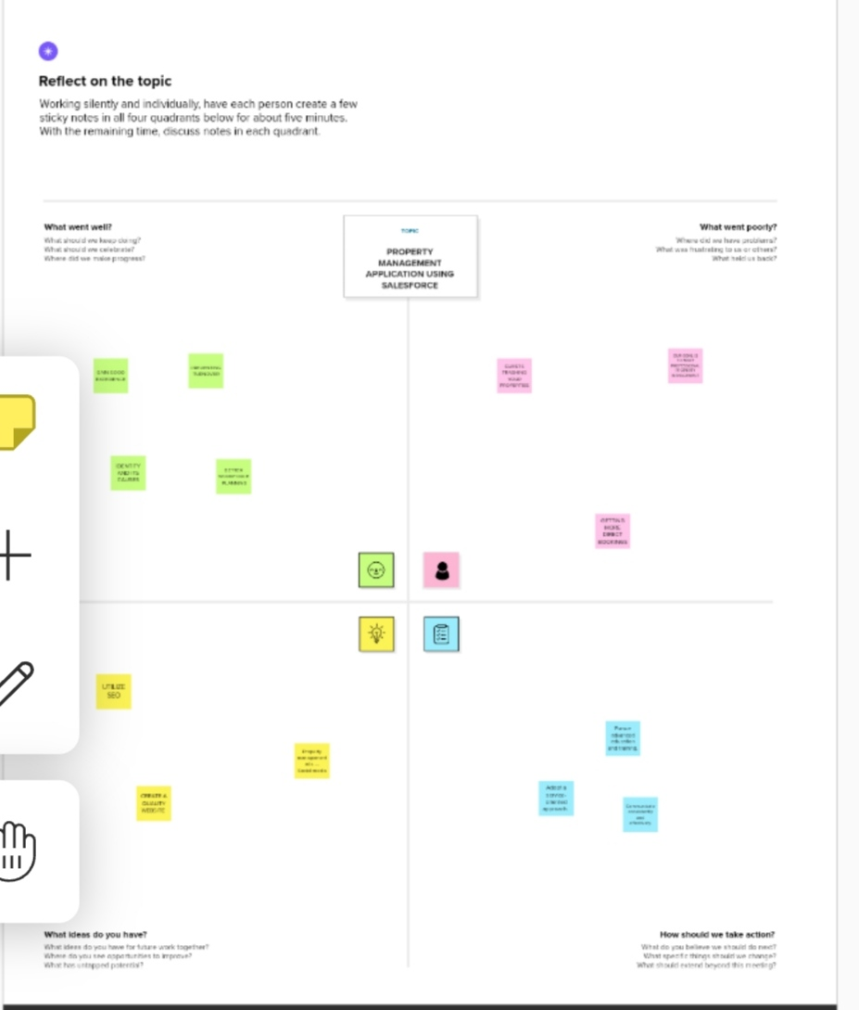

**2.2 Brainstorming:**

Brainstorming is a group problem-solving method that involves the spontaneous contribution of creative ideas and solutions. This technique requires intensive, freewheeling discussion in which every member of the group is encouraged to think aloud and suggest as many ideas as possible based on thiers diverse knowledge.

**PROPERTY MANAGEMENT…..BRAINSTORMING…..**

|  |  |
| --- | --- |
| PROJECT NAME | PROPERTY MANAGEMENT APPLICATION USING SALESFORCE |
| TEAM ID | NM2023TMID19554 |
| DATE | 15.04.2023 |
| NAME | DHANUSHKUMAR S |

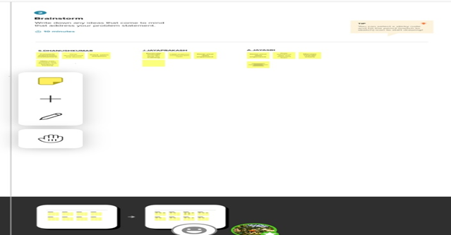

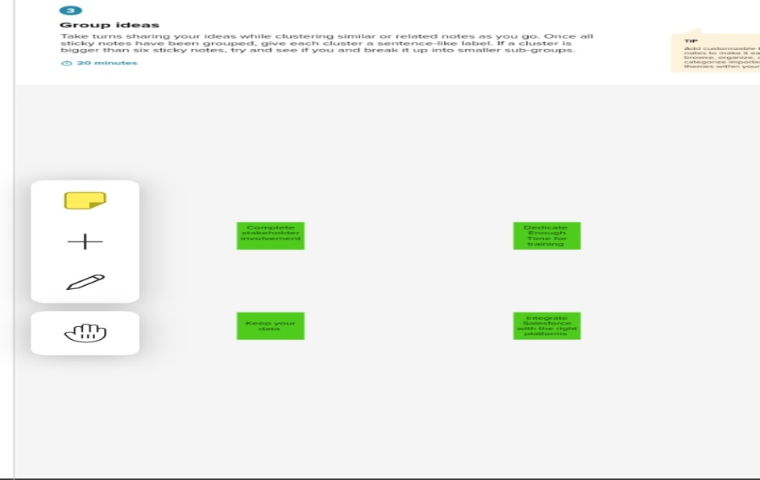

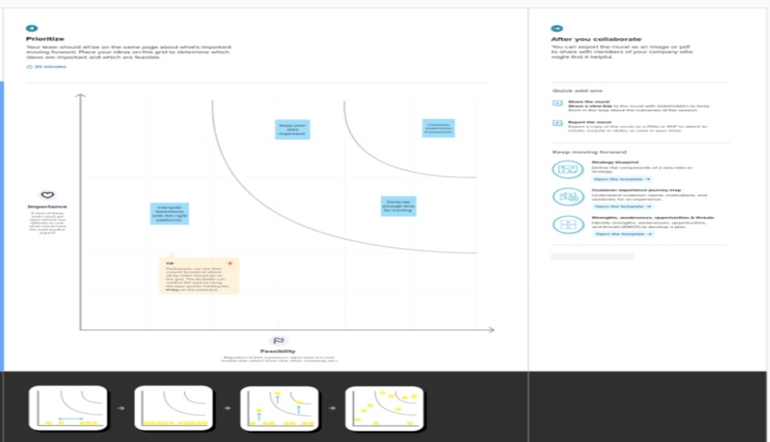

**3.RESULT**

**3.1 Data Model:**

|  |  |  |  |
| --- | --- | --- | --- |
|  | Object name | Field Lable | Text |
| 1 | Job positing site | Job Positing site | Text |
| Job Positing URL | Job Positing URL | Text |
| 2 | Review | Review | Auto-Number |
| Account | Account | Auto-Number |

**3.2 Activity & Screenshot:**

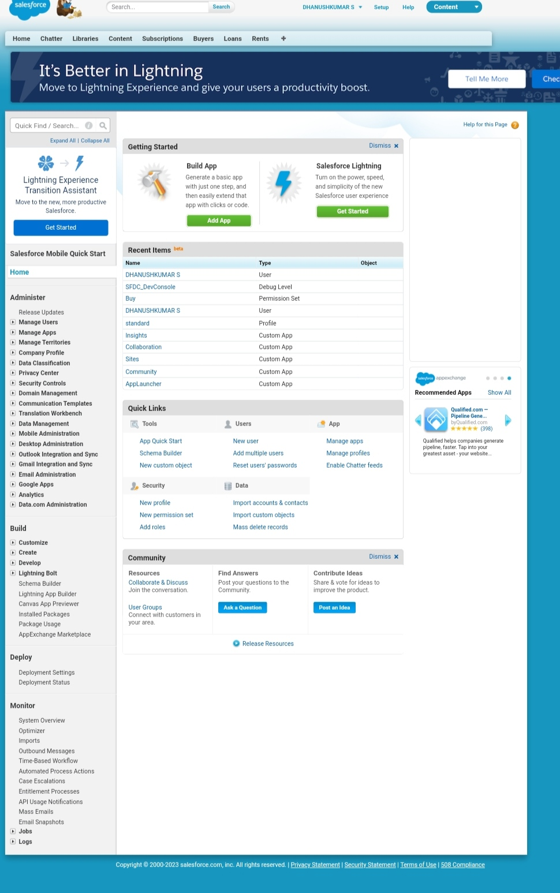

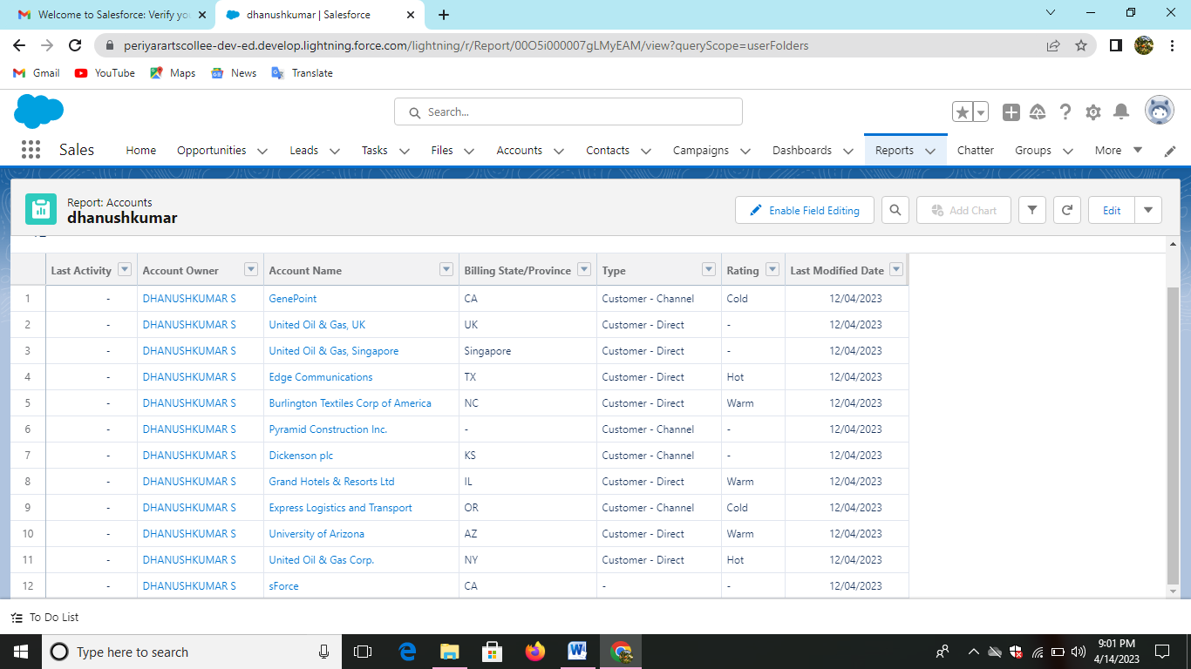

**4. TRAILHEAD PROFILE PUBLIC URL**

Team Leader - <https://trailblazer.me/id/dhans201>

Team Member 1 - <https://trailblazer.me/id/jjayaraman11>

Team Member 2 – [trailblazer.me/id/jayasrij669](https://trailblazer.me/id/dhans201)

**5.ADVANTAGES & DISADVANTAGES**

**Advantages:**

* Human resources planning
* Hiring workforce
* Enhance organization effe4ctiveness
* Handles disputes
* Motivating empolyees
* Improve employee relation.

**Disadvantages:**

* Costly setup
* Recesnt origin
* Unpresdictability
* Improper development programmes
* Insufficient information.

**6.APPLICATIONS**

* Property Management is a type of business application that enables companies to store employe information, manage common Property management functions, and execute critical activities such as processing payroll and administering benefits.
* Features oh Property management application include an employee self-service poprtal, payroll, workforces management, recruitment and hiring, benefits administration, and talent management.
* As mentioned, Property management applications are valuables for supporting critical property operations and initiatives. Let’s look at h0ow you an apply Property management capabilities in your business to deliver value and build a strong foundation.

**7.CONCLUSION**

In conclusion, due many challenges that are facing human resource departments, there is need for organisations to adopt correct and w3orkable policies that will not only ensure they alleviate these challenges but also develop mechanisms of Dellinger with such.

**8.FUTURE SCOPE**

The project has a very vast scope in future. The project can be implemented on internet in future.